Abstract— There is a growing number of Call for Tenders (CFT’s) published on the Web and it is important for businesses to be made aware of opportunities that match their capabilities when they occur. Although many large centralized tendering sites now exist, the freeform nature of CFT’s makes classification difficult. Furthermore many interesting calls are published on sites other than the major ones. This paper reports on the design and performance of a prototype web agent designed to ferret out new and interesting sites which publish CFT’s.
Looking for business
Zhen Zheng, Stéphane Vaucher, and Jean Vaucher

INTRODUCTION
For the procurement of expensive goods and services, governments and corporations rely on the call-for-tender process: publishing descriptions and conditions for what they need and selecting from submitted tenders. Currently, the trend is to publish Call For Tenders (CFT’s) on the Web and many government bodies have set-up major tendering sites which list thousands of CFT’s from their various departments. In Canada, MERX is an example; in the US, FedBizOpps.gov is the single government point-of-entry (GPE) for Federal government procurement opportunities over $25,000; TED (Tenders Electronically Daily) is the equivalent for the European community. Other organizations, such as SourceCan , provide an aggregation service by collecting and indexing documents from other sites.
A quick look at SourceCan (october 2004) shows clearly the importance of this phenomenon: it shows 3400 open bids from Canadian sources, 14,000 from US government sites, 33,000 European Union public tenders, 2100 for the World Bank and over 20,000 more opportunities from other sources. However, this abundance of listings hides very real problems when it comes to exploiting the data. First, there is no unique standard format for these documents. Most are loosely structured and meant for human interpretation; some documents are quite detailed whereas others are limited to a one-line title. Secondly, product codes – when they are used – may follow different standards. Indexing is therefore partial and approximate. The sheer volume means that effective monitoring of these sites must be done automatically; but the automatic classification of CFT’s and identification of pertinent opportunities is difficult.
This situation motivated the launch of a joint university / industry research initiative with researchers from the Université de Montréal, Nstein and CIRANO. The project, "Matching Business Opportunities on the Internet" or MBOI for short, is aimed at developing systems which can find and classify CFT’s accurately. It has several facets: one deals with the design of collector agents that systematically visit known sites and download new documents. Another, the biggest, concentrates on the natural language analysis and classification of documents [2,7]. This paper considers the design of discovery agents responsible for finding and mapping new CFT sites so that they can be exploited by the collector agents.
In spite of the volume of data concentrated in the major sites listed above, it is important to continuously scour the Web for others. One reason is that many call for tenders, linked to local governments, utilities (like Hydro-Quebec) or particular industrial sectors (like Construction, Transportation or Wood) are published on local sites and not listed on the major ones. This was confirmed by our initial studies. During the last year and a half, the MBOI collector robots visited about 35 sites daily in addition to the major sites listed above. On average, about a third of the 1000 new listings found daily came from the smaller sites. These are especially important because, for many companies, CFT’s closer to home are easier to take advantage of. A final justification for efficient continuous discovery is that sites are often reorganized and the scripts used by the collector agents no longer work. Over a year, we found that about half the sites changed and we had to rewrite collector scripts.
Our discovery agents are basically web spiders, but they target specific kinds of documents and the techniques they require are quite different from those used for commercial search engines (CSEs) like Google or Yahoo. Those systems cater to a heterogeneous clientele and their coverage of the web is broad but shallow. They need massively parallel search to handle the estimated million pages added to the web every day and must use techniques such as Page Rank [6] to rate Web pages objectively.
In contrast, we are interested in targeted search with a narrow but deep focus. In particular, we would like to search the invisible web [8] accessible only by entering data into forms and which is often not indexed by CSEs.
This problem was underlined by one of our students (J. Liu) who noted how hard it was to find Canada’s major site, Merx, by entering queries into Google. Another difference is that our agents are not primarily interested in documents; they are interested in sites which contain documents. This is because the sites are dynamic and the actual job of document retrieval is left to collector agents. A collector agent doesn't need a list of documents to retrieve; rather it needs a script detailing how to navigate a site and identify new CFT’s.
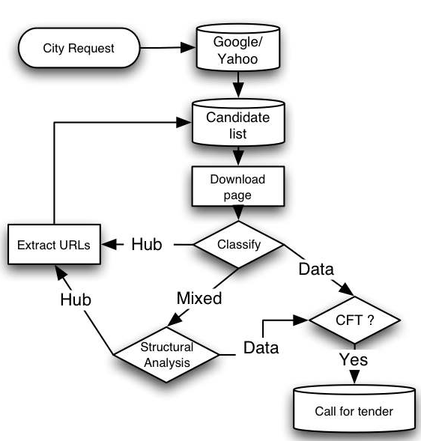
Figure 2. Architecture of the discovery agent

Early in the project, it became evident that intelligent discovery entailed the combination of a multitude of techniques and, in order to get good performance, each system component had to be adapted to the nature of the CFT domain. But proper evaluation and optimization requires the other components to be operational: in short we are faced with a bootstrap situation. Therefore it was decided to start with a rough prototype to evaluate the aptness of an initial architecture and the usefulness of available software packages. The objective was to get a complete system running that would serve as a test bed for more systematic development and evaluation of each component.
The prototype was tested on the task of finding the CFT’s of a city government given only the city name as starting point. Figure 1 shows how a human expert would do the job for the city of London, Ontario. Use of a search engine has brought us to London’s home page. From there, exploration of the site’s pages by following links with appropriate labels can lead to a directory of CFT’s in PDF format. This is the automatic navigation that our system is designed to do. In what follows, we present what we learned from building the prototype.
The paper is organized as follows. In Section 2, we briefly review current research and list the techniques that should be incorporated in a focused spider. In Section 3, we describe the architecture of our system, comment on the public domain software tools that were used and present some experimental results that show the performance of the system and led to the heuristics used in various modules. Finally, Section 4 gives some conclusions.

Web Spiders
A spider is a program designed to explore (crawl) the web to find new pages. To do this, it uses two data structures: a list of candidates, links (URLs) to pages it is planning to crawl, and a set of visited pages. Its work is repetitive: at each cycle, it selects a link from the candidate list and proceeds to download the corresponding page. This page is added to the visited set and parsed quickly to extract any links to other pages. These links are checked against the set of visited pages to see if they have already been visited. If not, they are added to the list of candidates. When used with a search engine, the downloaded pages are also passed to the indexing system which will extract keywords or attempt to classify the page content before placing it in its data base. Here, we talk about one spider, but in a commercial system where speed is paramount, there may be several thousand spider threads or processes working in parallel and the main problem is to distribute the load between machines and avoid duplication of work. Note that these spiders are not intelligent; they only care whether a page is old or new.
In 1999, in answer to the rapid growth of the Web, Chakrabati et al. [5] introduced the notion of focused crawling whose “goal is to selectively seek out pages that are relevant to a pre-defined set of topics.” The idea is to grade the candidates so as to explore links that are thought to be most relevant to the crawl. Discriminatory crawling of this type requires an evaluation function that can provide a measure of the pertinence of any given page or at least provide a boolean result: is the page interesting or not? But this does not totally eliminate our problem. The evaluation function can only tell us post facto whether the page we downloaded was good or not; what we really need is a way to choose between pages before retrieving them. In order to do this, focused crawling makes an assumption of topical locality: pages which are relevant are likely to point to other relevant pages. Candidates are thus graded based on the pertinence of the pages that referred to them and the score increases if several good visited pages point to a candidate. In this project, the evaluation used a classifier which was “trained with a canonical taxonomy (such as Yahoo!) and a corresponding set of examples.” The user expressed his preferences by selecting nodes in the taxonomy. The rate of relevant page acquisition was reported to be around 40%. Of course, this success is relative: it shows that pages placed in category X by this classifier are likely to point to other pages that would be classified the same way. Whether a human would judge the pages similar or relevant is another matter.
Two years later, Aggarwal [1] proposed an improved method which he termed intelligent crawling. In this work, the user is given a more flexible method to indicate her preference. Pertinence is determined by an arbitrary boolean predicate. However, the actual examples shown resort to a classifier (e.g. …page is in Yahoo/TRAVEL category) combined with keywords ( e.g. …and contains the word Paris ) and are not that different from those of Chakrabati. The main idea in the paper is that the potential interest of the page referenced by a given link can be estimated better if more factors are used. Aggarwal et al. use 4 kinds of information and the weights to be attributed to each are learned as the web is crawled. The factors include topical locality described previously; sibling locality: if a web page points to interesting pages its uncrawled links are likely to point to other pertinent pages. A third factor is the set of words in the referring page and the last is the tokens in the URL itself. Typically, the results show success rates over 80% achieved after crawling a few thousand pages. This success depends on learning the parameters of the evaluation function but also on the crawler finding its way to good sites relevant to the chosen topic. However, the article shows that the crawler could move from irrelevant starting pages to more interesting ones – a prerequisite for discovery robots.
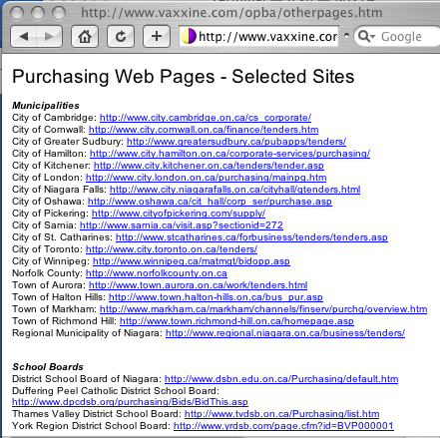
Figure 3. A typical Hub page

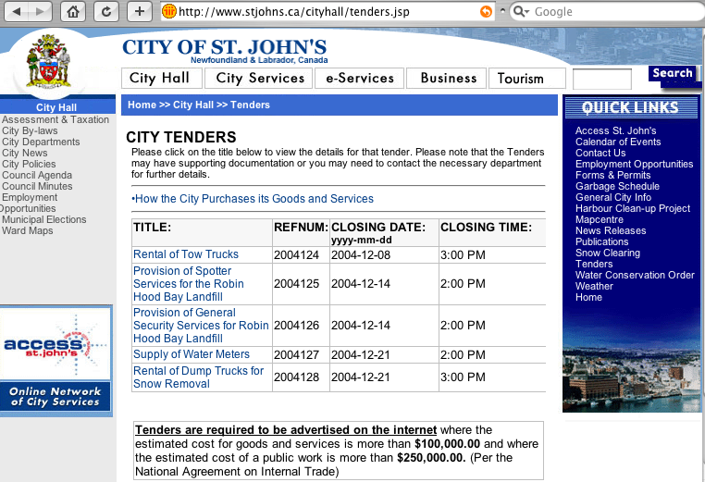
Figure 4. A typical mixed page with a central CFT Hub surrounded by generic menus

As the web has matured, new problems have emerged for crawlers. First is the increasing variety of formats. Early crawlers were designed to crawl HTML and TEXT files. Now, many web pages, especially those with the real data are in other formats such as PDF or WORD and classifiers must be able to handle those formats. Secondly, many interesting web sites require complex navigation: including login-in, and tunneling [3] through several pages before entering queries in forms to obtain dynamically generated pages. Often the web sites also use cookies to retain state from one request to the next. This may be quite natural to a human user but requires sophisticated scripts and specialized packages to reach interesting pages. This is the invisible web, which search engines cannot or refuse to index. Finally, the format of pages from commercial sites has reached a high level of sophistication with much repetitive decoration and standard link menus surrounding the core information. Specialized techniques are required to discard this decorative noise [4].
It becomes clear that discovery agents must combine a multitude of techniques that would have to be adapted to the reality of the Call-For-tender web sites.

Architecture of the system
Figure 2 shows the architecture of the system. Given the name of a Canadian city, the system adds appropriate terms to create a request which is submitted to a Commercial Search Engine. The URLs from the response are then used as starting points for exploration. The most interesting part of the system is the classification of pages as either hub or data pages and analyzing each type differently. Data pages contain mainly text information (and could be CFT’s) whereas hub pages contain mainly links that should be explored further. Figure 3 shows a typical hub page. Another is shown at the bottom of Figure 1, it points directly to several CFT documents in PDF format. It is this type of hub page that is most useful for collector agents.
More typical of what a crawler has to contend with is a mixed page – as shown in Figure 4 - containing both CFT’s and links to further pages. Here the system must break down the page into its constituent parts and decide which are links and which are data as well as which are the most important.
We now consider the tests that were done to optimize performance of the various parts of the system.

Semantic classification
Crucial to any intelligent crawler is the ability to classify pages in order to recognize what it is looking for: in this case, Call for Tenders. It is ironic that the major thrust of the other groups in the MBOI project is classification; but it is the classification by product class of documents that have already been identified as CFT’s, not the determination whether a document is a CFT or not. Furthermore, the requirements for our classifier, which has to select promising pages rapidly from a mass of candidates, are different from those of a batch classifier for which the criterion is accuracy.
To design a rapid and efficient classifier, we analyzed the words used of a set of call-for-tenders. We found that words typically found in a CFT could be placed in 6 different semantic categories (in bracket, we show the frequencies from our initial sample):
1) CFT synonyms: tender(83), tenders(24), bid(23), bids(12), rfp(17), quotation (16), solicitation(2), proposal(12) etc.
2) time tag: closing(13), closed(20), opening(33), open(13), pending(74), date(34), issued(23) etc.
3) purchasing words: request(40), contract(40), contact(35), purchasing(30), delivery(10) etc.
4) document synonyms: document(31), addendum(40), information (20)
5) address words: add (35), city (26), street(15), road(12), mailing(35)
6) others: deposit(14), awarded(13), buyer(13)
After several trials, we settled on a fairly simple classification scheme: to be recognized as a call-for-tender, a document should contain at least 2 words in each of the first three categories.

Using commercial search engines
In our architecture, given the name of a city, we start the search with a request to a commercial search engine adding other terms to focus the query. Which engines and what terms should we use?
First, we ran some tests to compare five commonly used search portals: ALTAVISTA, GOOGLE, LYCOS, MSN, and YAHOO. For each site we tried the same queries: “Ottawa tender” and “Ottawa RFQ” (request for quotation), and noted the number of hits indicated. The results are shown below.
Order | CSE | Query Term | Coverage
1 | GOOGLE | Ottawa tender  Ottawa RFQ | 57,000  2,490
2 | YAHOO | Ottawa tender  Ottawa RFQ | 36,400  2,250
3 | LYCOS | Ottawa tender  Ottawa RFQ | 26,466  552
3 | ALTAVISTA | Ottawa tender  Ottawa RFQ | 20,196  496
3 | MSN | Ottawa tender  Ottawa RFQ | 19,647  637
Table 1. Comparison of CSE (Coverage)
Google and Yahoo cover respectively many more pages than the other three (AltaVista, Lycos & MSN), but it is not enough to get many hits (coverage); a user wants precision: useful and pertinent hits. To test for this, we examined the first 20 URLs returned by each search engine to decide on the pertinence of each result. We respectively input a query term “Manitoba tender” to each CSE (see the Table 2). Not only do Google and Yahoo indicate more hits, the precision of the results is also much higher than the other three.
Order | CSE | Query Term | Coverage | Precision
1 | GOOGLE | Manitoba tender | 33,700 | 35%
2 | YAHOO | Manitoba tender | 22,700 | 30%
3 | ALTAVISTA | Manitoba tender | 10,350 | 25%
4 | MSN | Manitoba tender | 10,026 | 25%
5 | LYCOS | Manitoba tender | 13,396 | 10%
Table 2. Comparison of CSE (Coverage & precision)
Based on these experiments, Google and Yahoo were chosen as the our Search Engines of choice.
 | Query Term | Responses | Good Results  (in top 30) | Precision
1 | Ottawa tender | 57,900 | 19 | 63.3%
2 | Ottawa tenders | 15,800 | 25 | 83.3%
3 | Ottawa tender closing | 8,390 | 29 | 96.7%
4 | Ottawa tender or tenders | 70,400 | 18 | 60 %
5 | Ottawa tender -tenders | 51,300 | 11 | 36.7%
6 | Ottawa tenders -tender | 10,400 | 25 | 83.3%
Table 3. Query term comparison for Ottawa

 | Query Term | Responses | Good Results  (in top 30) | Precision
1 | Calgary tender | 33,700 | 18 | 60%
2 | Calgary tenders | 7,900 | 27 | 90%
3 | Calgary tender closing | 5,290 | 29 | 97%
4 | Calgary tender OR tenders | 38,700 | 18 | 60%
5 | Calgary tender -tenders | 30,300 | 13 | 43.3%
6 | Calgary tenders -tender | 4,740 | 24 | 80%
Table 4. Query term comparison in Calgary

Now, what words should we add to the city name to get pertinent URLS? Previously, we noted that most CFT’s included the term TENDER but that term could also be found in music pages (Love me tender…) or food pages ( …cook until tender…). We therefore tried various alternatives to lift this ambiguity and ran tests on Google using “Ottawa tender”, “Ottawa tenders”, “Ottawa tender closing”, “Ottawa tender –tenders” (“Ottawa tender” but without term tenders) and “Ottawa tender OR tenders”. The top 30 responses were checked manually to determine if they were related to procurement activity. Results are shown in Table 3 and results with another city, Calgary are shown in Table 4.
In terms of precision, best results are obtained by combining words from the two semantic groups that we judged the most effective in identifying CFT documents: tender and closing. However, in doing so we exclude many CFT documents for which the term tender was the most common identifier. As a result, we decided to extend the query with just “tender” and leave the filtering of extraneous answers to our system.

Structural classification
An important decision in the architecture is to differentiate leaf pages (containing mostly data) from the internal node pages which contain mainly pointers - these are often referred to as hubs. We call this distinction structural classification. A simple way to do this is to consider the ratio of LINKS [with HREF tags] to WORDS, tokens located outside of HTML tags. If the ratio is above 10%, we consider the page to be a HUB; if it is below 1%, we consider the page to be DATA. In between, a page is considered MIXED and needs further treatment to extract pertinent and coherent sections. DATA pages are passed to the semantic classifier (described above) which filters and keeps the CFT’s.
In a HUB page, we extract the links and keep any where the anchor text (between the <href> and </href> tags) contains the keyword tender (or tenders). If no such link is found, we presently do a limited form of tunneling by then looking for links with the term business as anchor.
The crawler was also designed for another form of tunneling. It identifies interactive pages with simple search capability: HTML forms within which the keyword “search” appears. The software is able to enter search terms and activate the request, in the same way as we query search engines; however, we have done no experiments as yet with this feature.
Many pages, as shown in Figure 4, are MIXED with both data and links. This is more and more the case with commercial sites which generate pages dynamically and often use multi-level tables to surround the data in each page with company defined standard elements like a LOGO or a menu of recurring pointers. These require special treatment based on Carchiolo’s ideas [4] to extract the most interesting part.

Mixed page handling
Most often, mixed pages are structured as imbricated tables - this is the case for the page in Figure 4 - and the trick is to pick which table - including its sub-tables – is the most pertinent. In the example below:
<table1> words_1
<table2>
words_2
<table3>
words_3
</table3>
</table2>
<table4>
words_4
</table4>
</table1>
Here are the 4 choices that could be retained along with their respective content:
Table1: words_1, words_2, words_3 and words_4
Table2 : words_2, words_3
Table3 : words_3
Table4 : words_4
After many trials, we settled on the following algorithm which picks table_{i} with the maximum value computed as follows:
val_{i} = nKW_{i} * nW_{i} / nL_{i} if L_{i} ≠ 0
nKW_{i} * 50 otherwise
where nL_{i} is the number of links, nW_{i}, the number of data words, and nKW_{i}, and the occurrences of relevant keywords in each section “i”. At this point, keywords only include the terms tender and tenders. This ad-hoc method provides a base line against which more sophisticated methods can later be compared.

Useful software packages
The design and construction of modern software is eased by the availability of high quality public domain packages. For our applications, the following software packages were used: HttpUnit, Lucene and HTMLParser.
HttpUnit is a suite of Java classes designed to test Web applications over HTTP. It emulates the relevant portions of browser behavior, including form submission, JavaScript, basic http authentication, cookies and automatic page redirection, and allows Java test code to examine returned pages either as text, an XML DOM, or containers of forms, tables, and links. HttpUnit is also very useful for collector agents because it provides a class, called WebConversation, to emulate an entire session and not just a single request. In particular, these objects can be tailored to fill out forms. Our crawler made heavy use of this package.
HTMLParser is a “super-fast real-time parser for real-world HTML”. It was our tool of choice to do the structural analysis of web pages.
Lucene is a Java library that can provide industrial strength text indexing and searching capabilities to an application. Its analyzers can be combined to extract indexable tokens, remove stop words, do case-conversion and stemming. Lucene was used to normalize the page text before doing semantic classification.

Results and conclusions
The prototype described here has been quite successful in discovering call for tender pages on the web sites of the cities we tested it with. To achieve this goal, the agents had to combine many techniques and heuristics. Here are some of the ideas that were tested in the prototype:

- Use of existing search engines to find good starting points for further exploration.
- Analysis of page structure before examining content. We distinguish HUB, CONTENT and MIXED pages and each is treated differently.
- Pages with a complex HTML structure (i.e. Tables) are analyzed specially to extract the information core.
- Use of a keyword profile to quickly evaluate the relevance of pages.
- Use of several off-the shelf public domain packages.
Preliminary comparisons with Google show that our system’s precision is twice that of Google (about 60% to 30%). More details can be found in [9]. Full evaluation of the performance will have to wait for the next phase of the project; but already it is apparent that the main problem to achieve smart navigation of the web is in the design of classifiers that can detect satisfactorily what is a relevant page and what is not.
Typically all pages found and accepted by our system deal with CFT’s in the given city. But most are not CFT’s: some are news stories about contracts, others refer to the terms and conditions of doing business, others are hubs, etc… An automatic classifier is at the heart of any intelligent discovery agent, but it is not evident how to design a classifier that could learn the subtle differences between these documents.
On the other hand, if we consider the discovery agent as a useful tool in a computer assisted (rather than a fully autonomous) system, its value is evident: 1) from the data found, it is relatively easy for a person to identify the relevant CFT hub pages and write collector scripts and 2) the pages returned amount to interesting business intelligence.
Now that we have a working prototype, we will concentrate on the design of a good classifier as well as evaluating the effectiveness for CFT discovery of the page and link attributes proposed by Aggarwal. We also want to study the best ways to tunnel through to the hidden web pages by automatically filling out forms. Finally, we will design experiments to properly evaluate the performance of the system.

References
- C. C. Aggarwal, F. Al-Garawi, and P. S. Yu, "Intelligent crawling on the World Wide Web with arbitrary predicates," Proc. of the tenth international conference on World Wide Web, pp. 96-105, Hong Kong, 2001.
- J. Bai, F. Paradis, and J.-Y. Nie, "Web-supported Matching and Classification of Business Opportunities," Second International Workshop on Web-based Support Systems (WSS), Beijing, 2004.
- D. Bergmark, C. Lagoze, and A. Sbityakov, "Focused crawls, tunneling, and digital libraries.," ACM European Conference on Digital Libraries, pp. 91–106, Rome, 2002.
- V. Carchiolo, A. Longheu, and M. Malgeri, "Extracting Logical Schema from the Web," Applied Intelligence, vol. 18, pp. 341-355, 2003.
- S. Chakrabarti, M. van der Berg, and B. Dom, "Focused crawling: a new approach to topic-specific Web resource discovery," Computer Networks, 31 (Proc. Of 8th International World Wide Web Conference), pp. 1623-1640, 1999.
- L. Page, S. Brin, R. Motwani, and T. Winograd, "The PageRank citation ranking: Bringing order to the Web," Stanford Digital Library Technologies Project, http://citeseer.ist.psu.edu/page98pagerank.html, 1998.
- F. Paradis, Q. Ma, J.-Y. Nie, S. Vaucher, J.-F. Garneau, R. Gérin-Lajoie, and A. Tajarobi, "MBOI: Un outil pour la veille d'opportunités sur l'Internet," Colloque sur la Veille Strategique Scientifique et Technologique (VSST), Toulouse, France, 2004.
- C. Sherman and G. Price, The invisible Web : uncovering information sources search engines can't see. Medford, NJ: CyberAge Books, 2001.
- Z. Zhen, "Domain specific web search," MSc Thesis: Université de Montréal, 2004.

 Zhen Zheng is finishing his MSc at the Département d’Informatique (DIRO), Université de Montréal (e-mail: zhenzhen@iro.umontreal.ca). Stéphane Vaucher was with the CIRANO Research Center, Montréal. He is now doing his MSc at the Département d’Informatique (DIRO), Université de Montréal (e-mail: vauchers@iro.umontreal.ca). Jean Vaucher is a professor at the Département d’Informatique (DIRO), Université de Montréal (e-mail: vaucher@iro.umontreal.ca). Acknowledgments— This work was carried out with major support from NSERC as a joint research project with CIRANO and Nstein Technologies. It was presented at MCeTech2005, the Montreal Conference on e-Technologies, January 20-21, 2005.
http://httpunit.sourceforge.net/
http://jakarta.apache.org/lucene/docs/index.html
http://htmlparser.sourceforge.net/

